Experiment – 17
Question:
Change Hardware compatibility of a VM (Either by clone/create new one) which is already created and configured using vmware workstation.
Answer:
AIM: To change hardware compatibility of an existing VM.
SOFTWARE REQUIRED: VMware Workstation 17, Ubuntu ISO, Host OS: Windows
PROCEDURE:
STEP 1: Launch VMware Workstation
Click Start → VMware Workstation 17

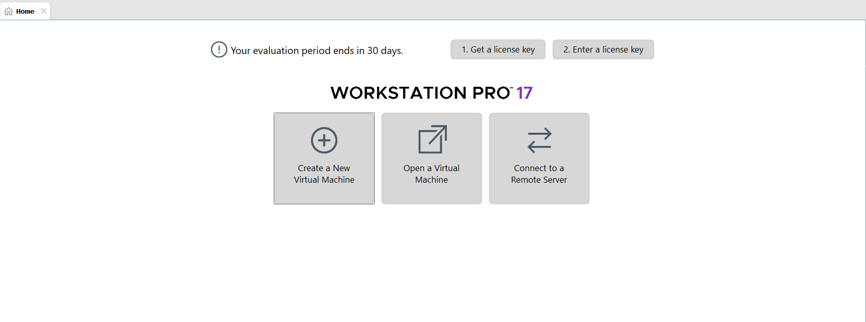

STEP 2: Create Virtual Machine
Click Create a New Virtual Machine
Select Typical (recommended) → Next
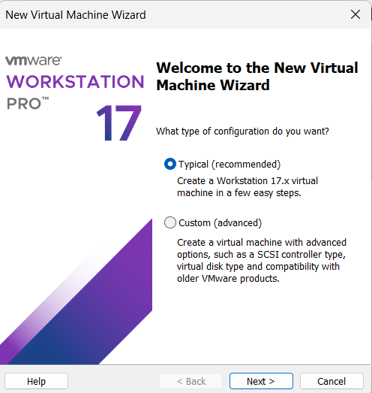

STEP 3: Select OS Installer
Choose Installer disc image file (ISO)
Browse and select Ubuntu ISO

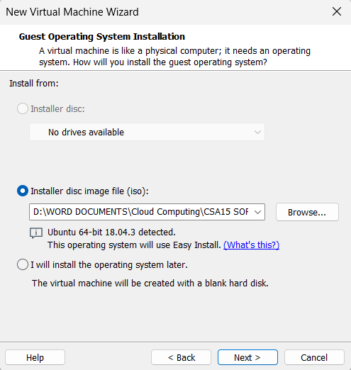

STEP 4: Name VM & Location
VM Name: Virtual Machine Ex-17
Choose location → Next
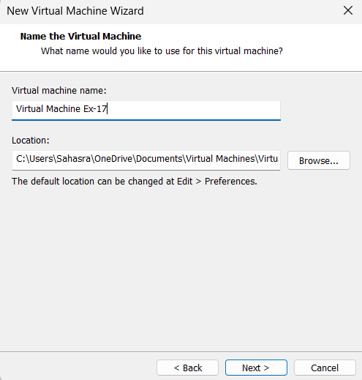

STEP 5: Finish Installation
Click Finish
Ubuntu starts installing automatically
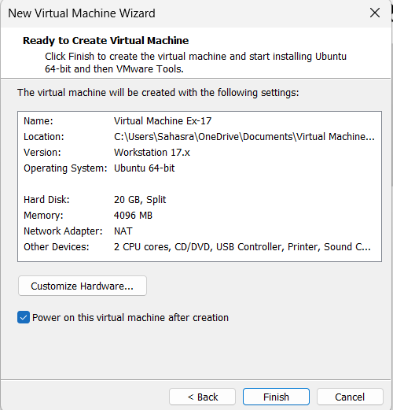

STEP 7: Save & Start VM
Click OK
Power ON the VM
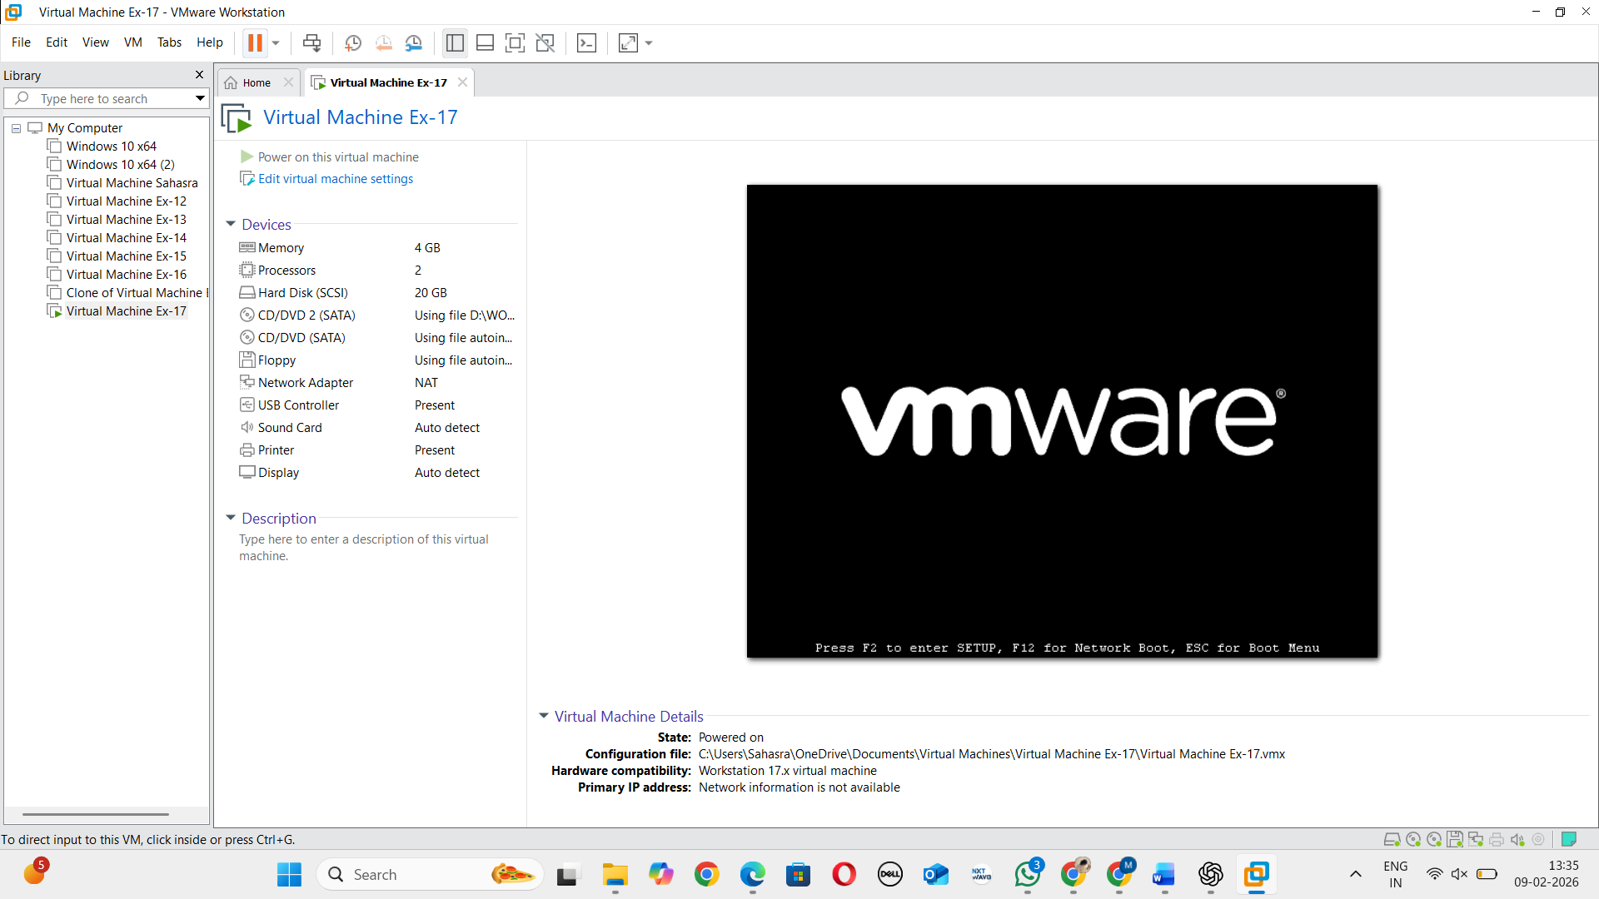

STEP 8: Power OFF VM
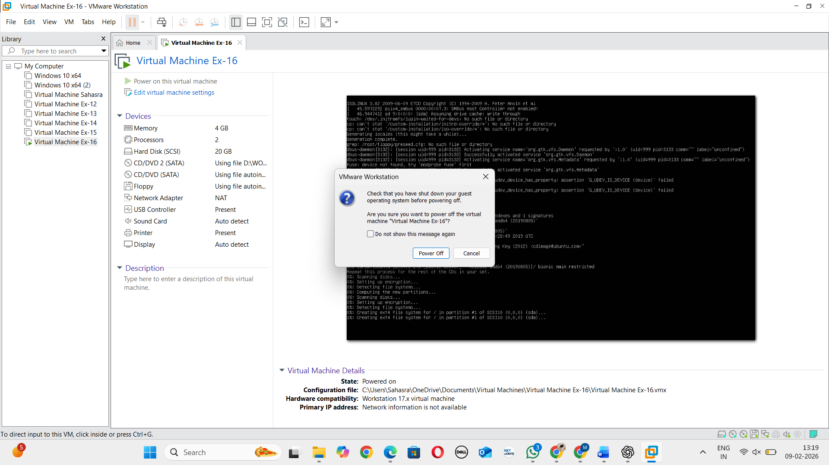

STEP 9: Change Compatibility
Right-click VM → Manage → Change Hardware Compatibility
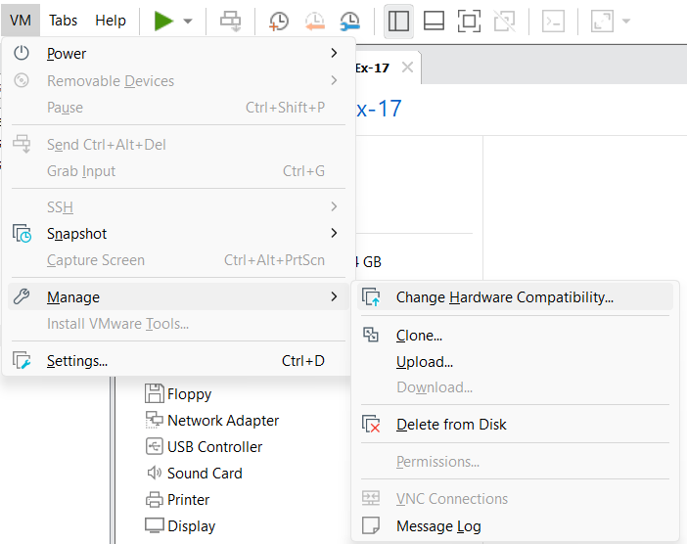
STEP 10: Select Version
Choose Workstation 16.2.x
Click Next → Finish
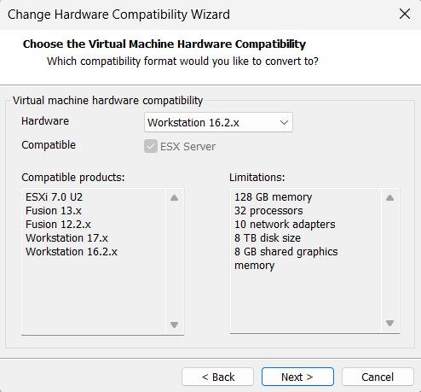

STEP 11: Name Cloned VM

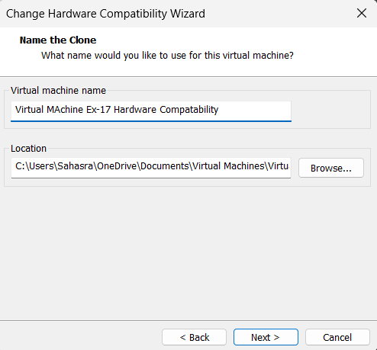

STEP 12: Click Finish

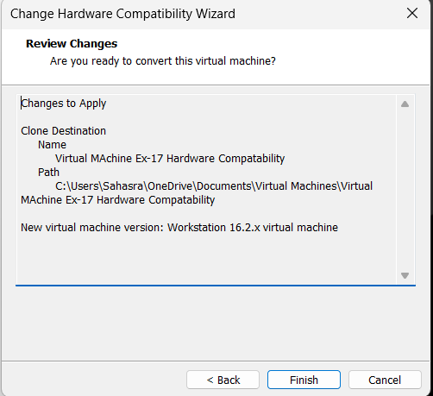

STEP 13: Power ON VM
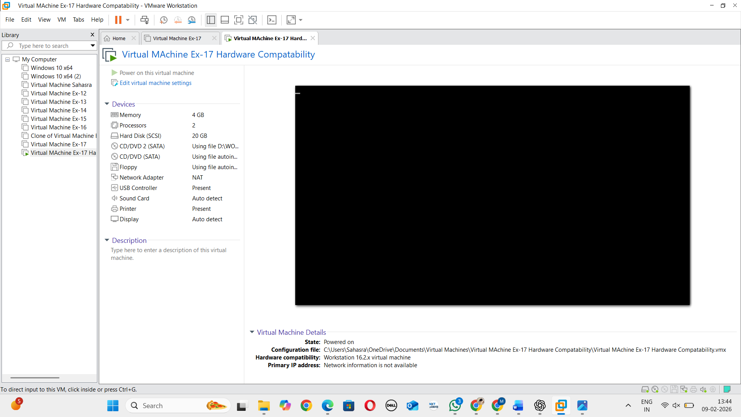

RESULT: Hardware compatibility of the VM is successfully changed.

